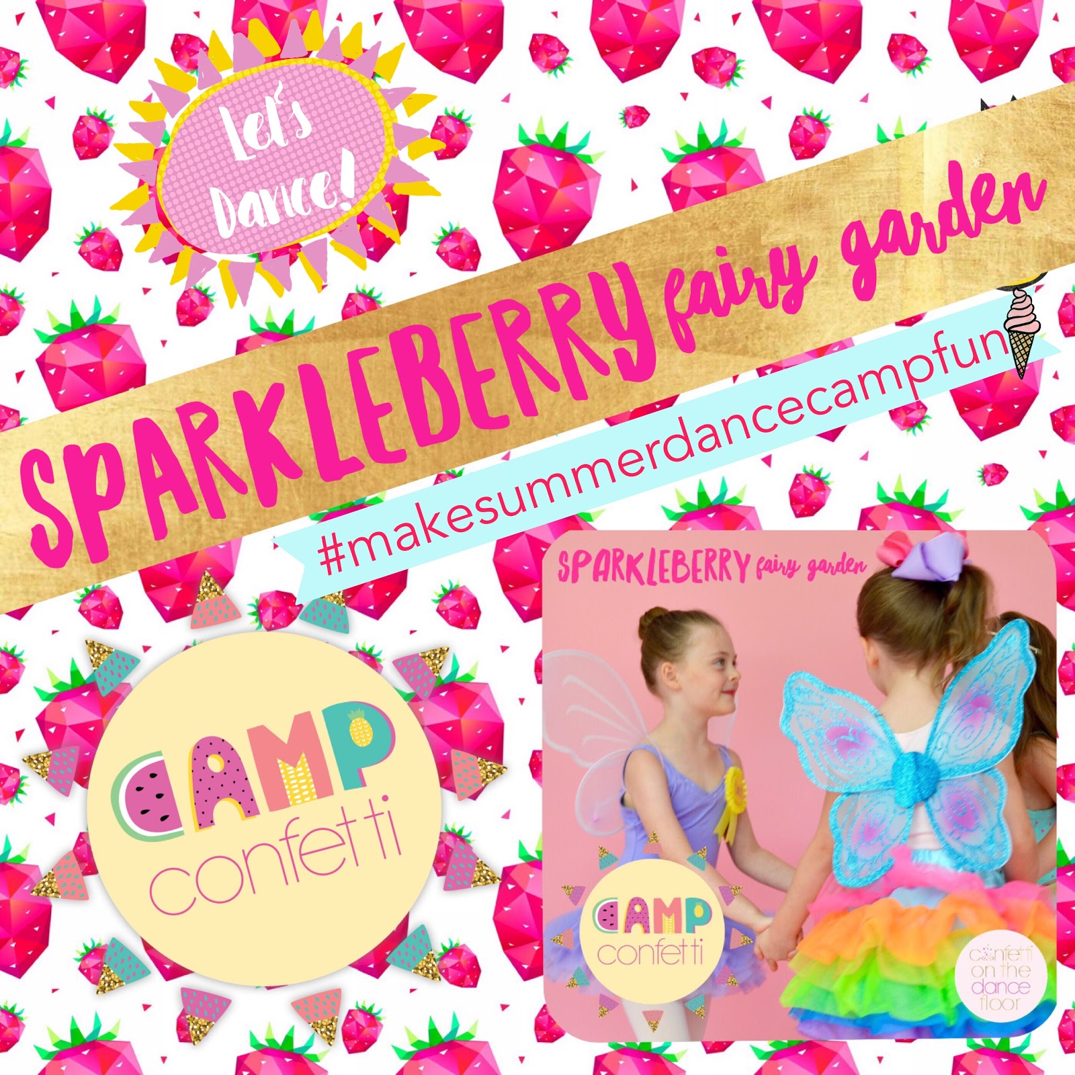
This magical camp is full of pixie dust, dancing, games, glittery crafts and so much more!

June 10-14

Ages 4-8
9:30-12:30
$125 ($115 before May 1st)

Ages 2-3
10:00-11:30
$65 ($60 before May 1st)

Big Bows In A Candy Store
Your little dancer will go crazy, crazy, crazy over this
Jo Jo inspired dance camp.

June 24-28
Ages 4-10
9:30-12:30
$125 ($115 before May 1st)

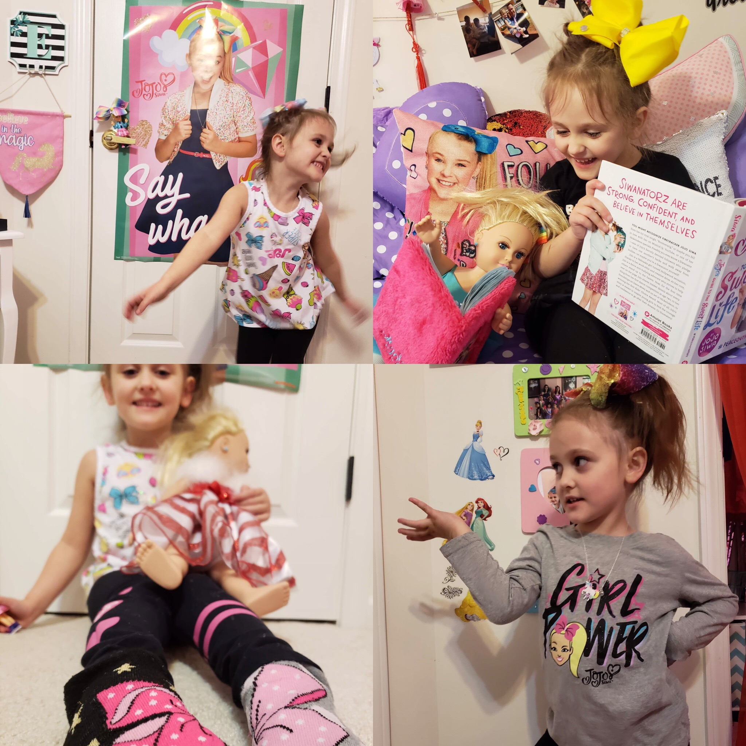

2019
Summer Camps

678-775-8113
gadanceunlimited.com

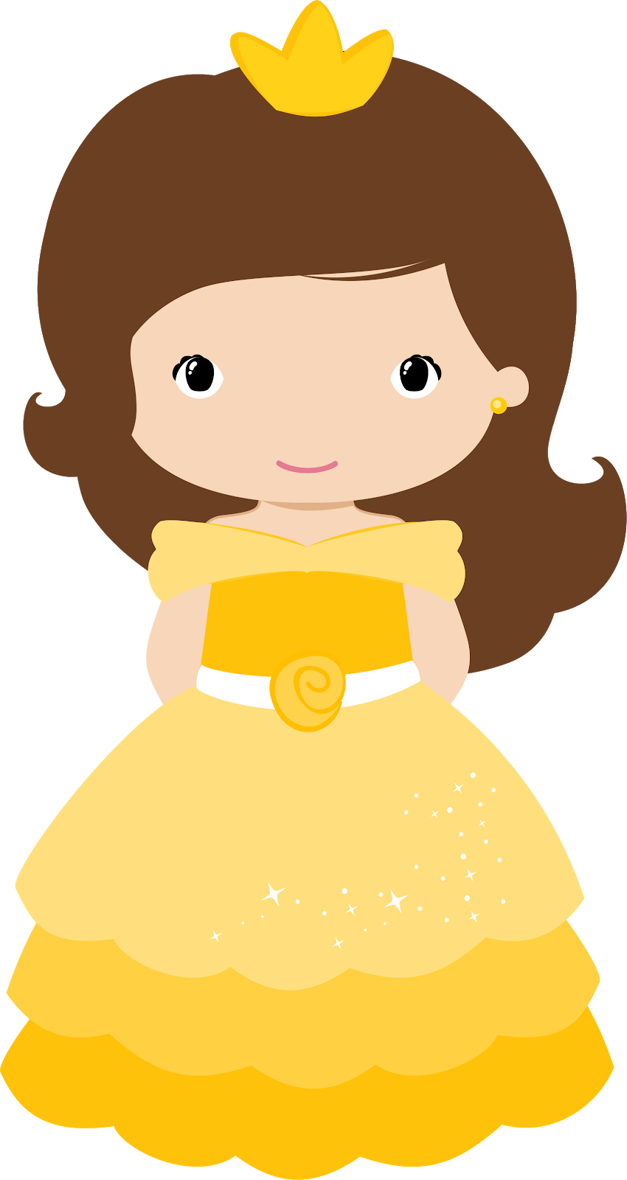
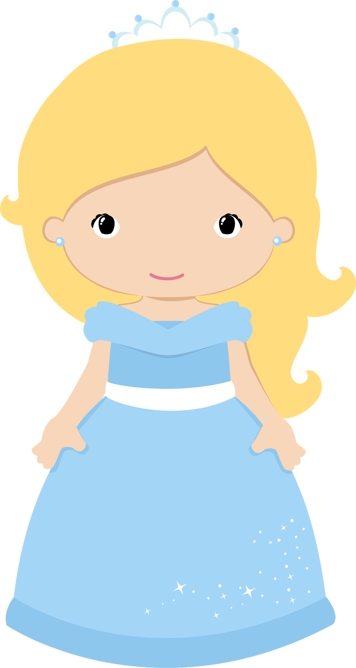

Magical Princess Camp

Every day will feature activities inspired by a different princess. Your princess will enjoy dress up, tea parties, dancing, crafts and more!

July 22-26

Ages 4-10
9:30-12:30
$125 ($115 before May 1st)

Ages 2-3
10:00-11:30
$65 ($60 before May 1st)

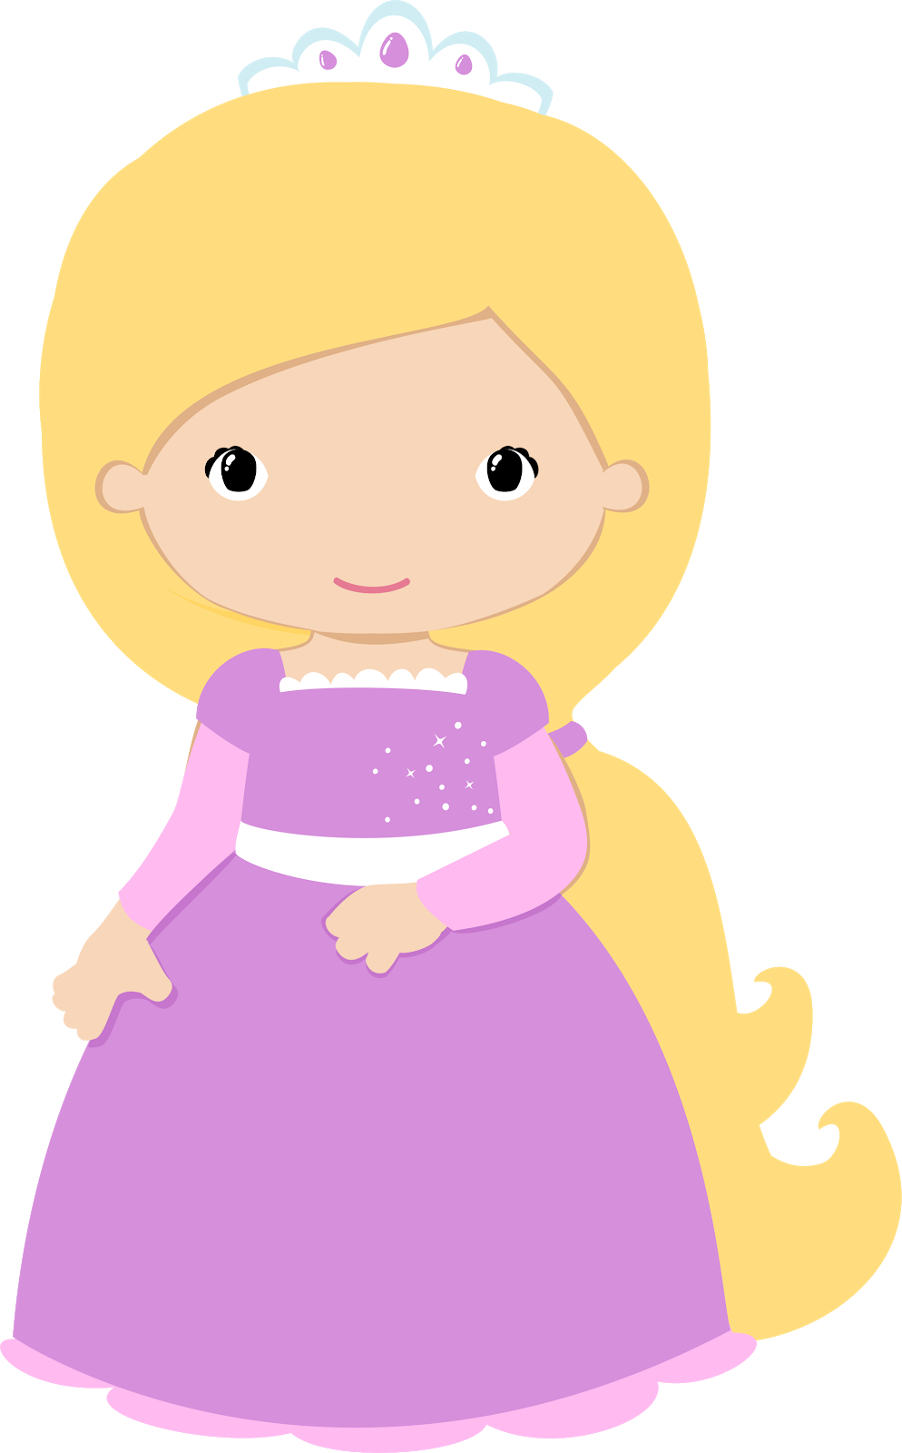
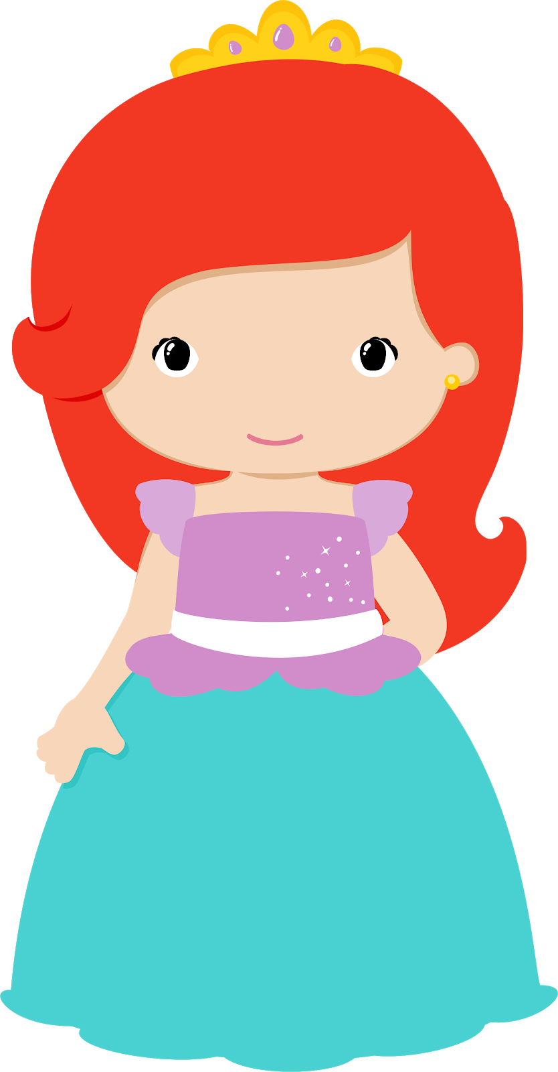
Frozen Fun Camp

July 15-19

Ages 4-10
9:30-12:30
$125 ($115 before May 1st)

Ages 2-3
10:00-11:30
$65 ($60 before May 1st)

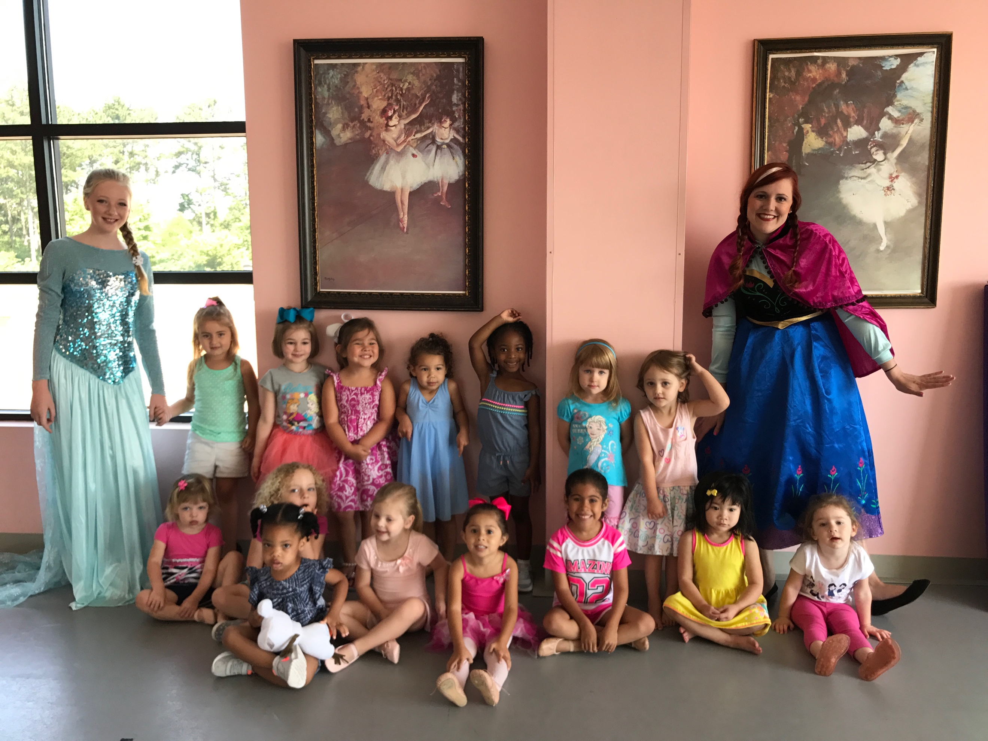
Magical Unicorns & Sparkling Rainbows

July 8-12
Ages 4-10
9:30-12:30
$125 ($115 before May 1st)

Ages 2-3
10:00-11:30
$65 ($60 before May 1st)

